**Second Review Document**

**Next-Gen Balance Management System**

Komal Gulati

Reg. No.

Mobile No.

Mail Id.

Guide Name

Designation

Mobile No.

Mail ID

**B.Tech.**

in

**Computer Science and Engineering**

**School of Computer Science & Engineering**

**®**



Table of Contents

1. Introduction 3

1.1. Theoretical Background 3

1.2. Motivation 4

1.3. Aim of the proposed Work 4

1.4. Objective(s) of the proposed work 4

2. Literature Survey 4

2.1. Survey of the Existing Models/Work 4

2.2. Summary/Gaps identified in the Survey 5

3. Overview of the Proposed System 6

3.1. Introduction and Related Concepts 6

3.2. Framework, Architecture or Module for the Proposed System 6

3.3. Proposed System Model 7

4. Proposed System Analysis and Design 9

4.1. Introduction 9

4.2. Requirement Analysis 9

4.2.1. Functional Requirements 9

4.2.1.1. Product Perspective 9

4.2.1.2. Product features 9

4.2.1.3. User characteristics 9

4.2.1.4. Assumption & Dependencies 9

4.2.1.5. Domain Requirements 9

4.2.1.6. User Requirements 10

4.2.2. Non-Functional Requirements 11

4.2.2.1. Product Requirements 11

4.2.2.1.1. Efficiency (in terms of Time and Space) 11

4.2.2.1.2. Reliability 11

4.2.2.1.3. Portability 11

4.2.2.1.4. Usability 11

4.2.2.2. Organizational Requirements 11

4.2.2.2.1. Implementation Requirements 11

4.2.2.2.2. Engineering Standard Requirements 12

4.2.2.3. Operational Requirements 12

4.2.3. System Requirements 12

4.2.3.1. H/W Requirements 12

4.2.3.2. S/W Requirements 12

5. Results and Discussion 13

6. References 14

# Introduction

## Theoretical Background

As per Reserve Bank of India (RBI), digital payment volumes have grown at a compounded annual growth rate of 55.1 per cent, from 5.93 billion transactions in the year to March 2016 to 34.35 billion transactions in the year to March 2020.

Some of the traditional account balance systems are either not able to meet the load or require much higher infrastructure which is making total cost of ownership as very high.

Traditional account balance system uses relational databases like Oracle / Postgres (RDBMS).

Many banks use Centralized database across country and also use same database for transactions as well inquiry / reporting.

The huge number of volumes puts a lot of load on the database. Online transaction processing thus becomes slow.

On other hand applications were not designed to handle such volumes.

In general applications update the balance table in database for every transaction along with insert into transaction table. As each transaction needs to lock the database row for balance, it is not possible to perform hundreds of transactions (debit or credit) on same account in same second. This is one of the major bottlenecks.

Second issue is as balance and transaction tables have lot of indexes insert and update of these tables becomes slow. Online API to debit (dr) or credit (cr) the account is not able to respond in less than 100 ms.

## Motivation

The challenge to solve the current problem itself is the motivation, as engineering finally is to solve the real challenges.

## Aim of the proposed Work

The aim of the proposed solution is handling huge transaction volumes with low latency (response time).

Additionally, there should be minimum disruption to the current system when new system is deployed. Banks may take some time to completely move to the new system and reture the old system, so need of hour is new system should be able to coexists with old system.

## Objective(s) of the proposed work

Objective is to ensure withdrawal and deposits can be performed with very quick response time, and higher throughput. Bank should be able to process more than 50 transactions on same account, currently this limit is around 10.

New system should ensure the transaction integrity, and should persist the transactions completely on disk before sending the response. Response cannot be sent just based on in-memory processing.

# Literature Survey

## Survey of the Existing Models/Work

In today's complex world, due to the increasing use of web-based programs, smart phones and social networks, production rate is increasing constantly as well as volume of data. Also, companies try to provide their services with more features in order to stay ahead of their competitors. That increases the production of information by the users too. In this case, it seems that moving from rational databases to non-relational databases in a necessity. With regard to the various of use cases and their requirements, also the primary features of NoSQL databases, choosing the most appropriate NoSQL database can be big concern of developers. The right selection of NoSQL databases will avoid to wasting time, money, and energy.

As organizations increasingly leverage applications hosted on different infrastructure, in different geographies, and with different providers, the speed at which end users can access those applications comes under pressure.

By leveraging a data layer that unifies your data across clouds and the globe, organizations can overcome some of the inherent limitations that have challenged technology teams for decades and deliver better experiences to their end users. different providers, the speed at which end users can access those applications comes under pressure.

## Summary/Gaps identified in the Survey

Most solutions found in survey purely depend upon in memory database, or noSQL databases. They do not provide the persistent and reporting capability of RDBMS. They do not have ACID property of the database, they provide eventual consistency, which is not acceptable for banking account balances. So, either we get the speed, or functionality, bank needs both.

# Overview of the Proposed System

## Introduction and Related Concepts

A new balance management system will be developed, which will utilize the power of in-memory REDIS database in addition to that of RDBMS. No bank will agree to depend purely upon in memory database for financial transactions. Design will ensure that the combination of RDBMS and in memory will deliver faster performance due to REDIS, but still have persistent and transaction integrity benefits of RDBMS.

Asynchronous and bulk processing will be used to remove the bottleneck of RDBMS.

## Framework, Architecture or Module for the Proposed System

In the proposed architecture, new Balance Management System will perform update of balance in REDIS, instead of database. Insert of transaction will be done in new transaction table which will have only 2 to 3 indexes.

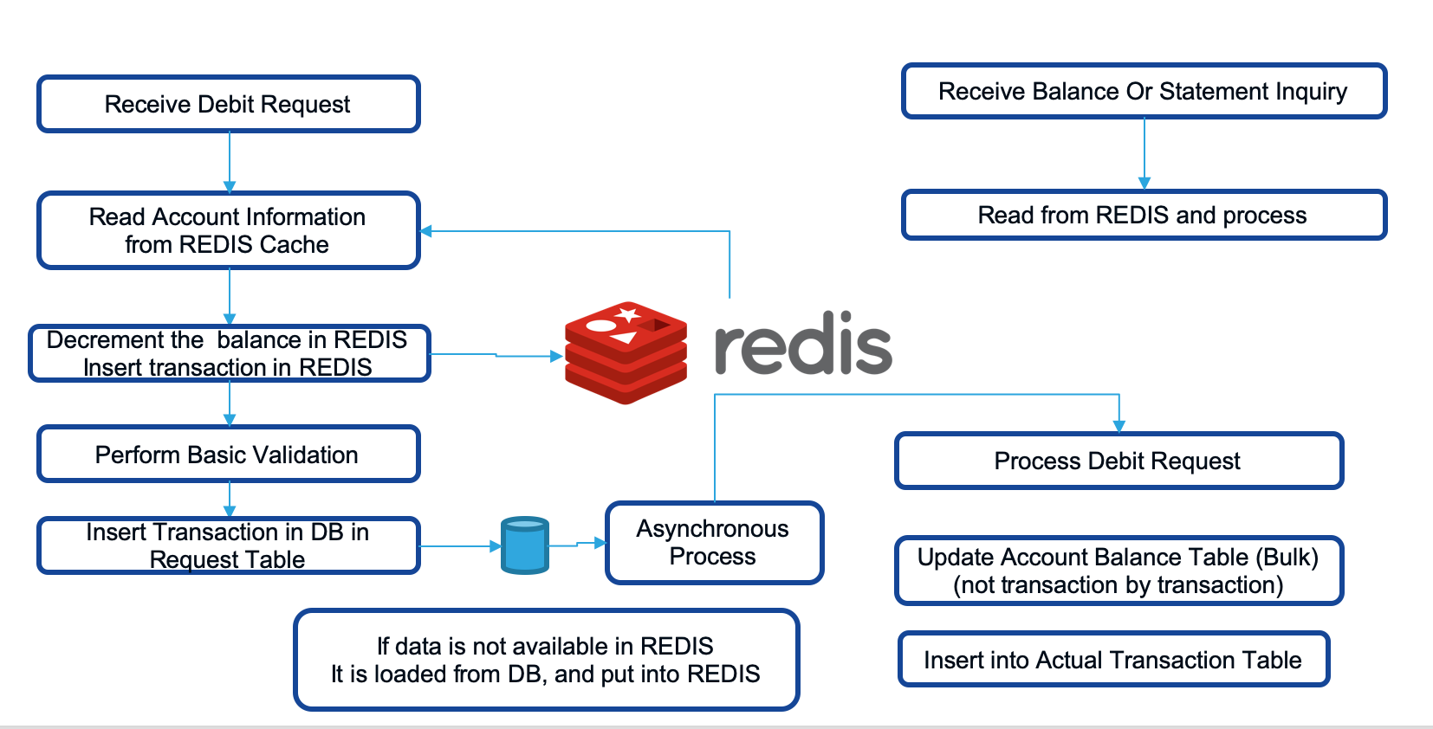

For inquiry or reporting purpose data will be inserted from new transaction tables to old transaction tables in bulk. DBMS performs better when data is written in bulk instead of transaction by transaction. Number of updates will reduce for those accounts where lot of transaction happens in same second.

## Proposed System Model



Sequence Diagram (Withdrawal)

x

Sequence Diagram (Deposits)



ER Diagram

# Proposed System Analysis and Design

## Introduction

The main design concentrates on mixing REDIS and RDBMS usage. Additionally, the design is different for withdrawal and deposits type of transactions. Bank always wants to play conservative when it comes to withdrawal. On other hand bank need not put the overhead of debit, in case of deposits.

## Requirement Analysis

## Functional Requirements

## Product Perspective

This solution can be productized as this is required by all banks. There is huge reuse of the solution. It can work on top of any banking solution.

## Product features

The important features are

* Support Withdrawal
* Support Deposit
* Support Transfer of funds.

## User characteristics

From user prospective, there need not be change in current interface or functionality.

It is more of performance and scalability of the solution which matters.

## Assumption & Dependencies

The current solution also will be able to invoke APIs / Methods to get or update the data in REDIS.

## Domain Requirements

Most important domain requirements are listed below

* Debit to Account should not be allowed for amount more than the balance or limit allocated to the account.
* It should be possible to put daily withdrawal limit check
* It should be possible to put a limit on number of withdrawals in a month

## User Requirements

Most important user requirements are

* User should see the balance amount after the withdrawal or deposit into account
* Mini statement after the transaction should include the current transaction.

## Non-Functional Requirements

## Product Requirements

## Efficiency (in terms of Time and Space)

The response time of transaction should be less than 50 ms. This response time is measured within the data center. This does not include network latency to the data center.

## Reliability

The response time of transaction should be less than 50 ms. This response time is measured within the data center. This does not include network latency to the data center.

## Portability

System is portable on any unix server, however the development and testing will be done only on linux platform in current scope.

## Usability

The response time to the user should be very less.

## Organizational Requirements

## Implementation Requirements

Multiple Linux server will be required for high availability to run REDIS clouster.

## Engineering Standard Requirements

Standard API gateway / firewall / security components will need to be deployed with proper authentication and authorization features..

## Operational Requirements

Monitoring tool will be required to monitor the REDIS, database and application.

Log collector and monitoring will be required.

## System Requirements

## H/W Requirements

For development and testing, a single linux machine is enough, with small CPU / Memory requirements as given below.

Number of Cores : 2

Memory : 4GB.

For production it will depend upon transaction and account volumes.

## S/W Requirements

Following software are required by the application.

* Java / Spring Boot framework
* REDIS (Version 5 and above)
* Postgres / Oracle RDBMS

# Results and Discussion

jMeter Tool – for measuring the transaction API.

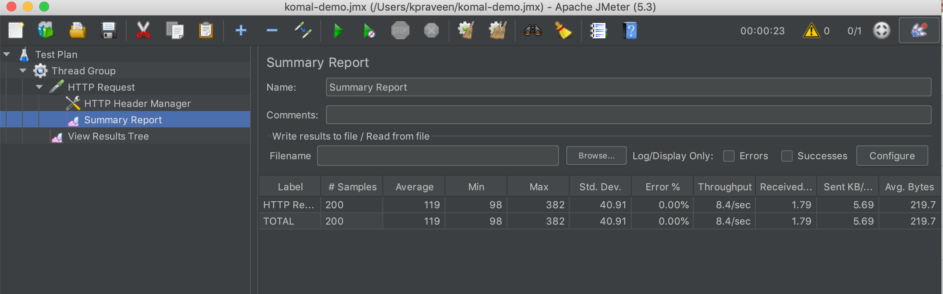

Above image shows result showing where the tool is running local and application is running in data center.

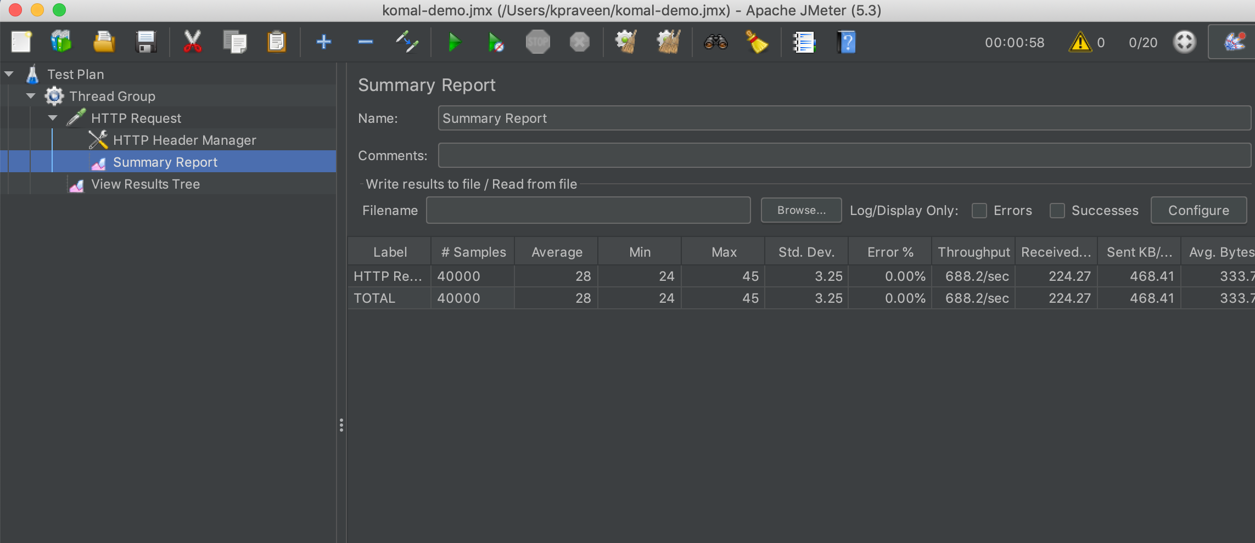

Average Response Time : 28ms

Throughput : 688 per second (20 concurrent users)

Error Percentage : 0

Number of requests tested : 40000

Above image shows result showing where the tool and application is running in same machine.

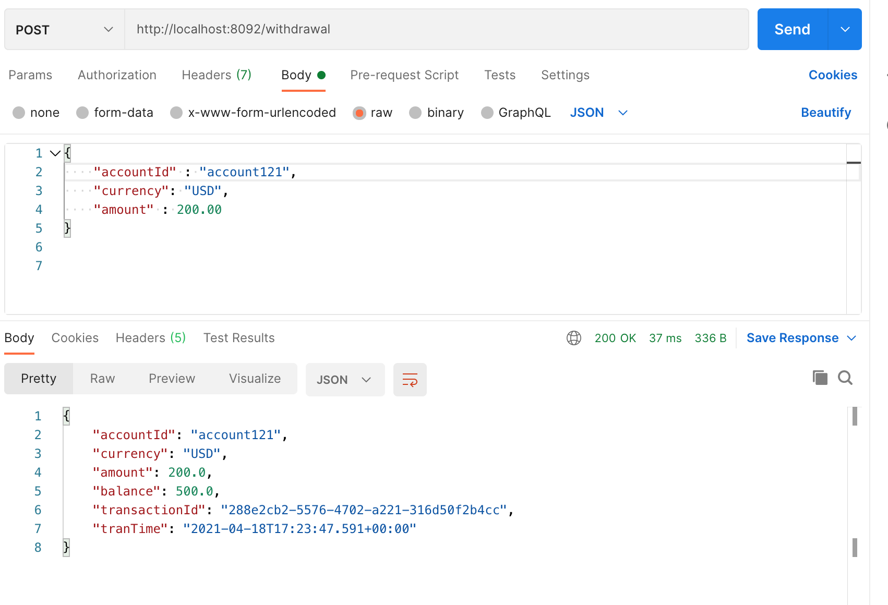

Above image shows the result using POSTMAN tool to test the API.

# References

1. <https://www.researchgate.net/publication/316217765_A_novel_method_for_evaluation_of_nosql_databases_A_case_study_of_cassandra_and_redis>
2. Latency is the New Outage (<https://redislabs.com/docs/latency-is-the-new-outage/>